**The Boomerang**

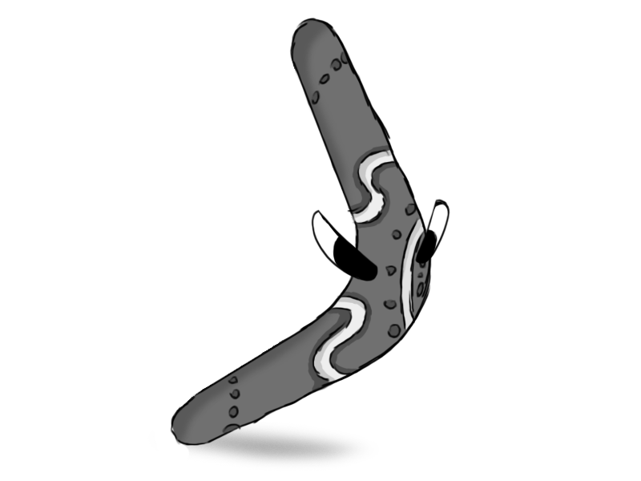

Figure 1 - Enemy: Boomerang

**Brief Synopsis**

The Boomerang is, as its name implies, a living boomerang that throws itself. It moves in wide arcs around the level trying to angle itself towards the player. if the boomerang collides with anything it will take damage or die and if it hits something with health it deals contact damage to it. This means, if the player were to redirect the boomerang with the staff into another enemy, they could kill both enemies at once. This would be somewhat difficult to do; however, it would provide a reward for high skilled players but also doesn’t punish weaker players heavily as they can still kill the boomerang normally with their usual attacks.

**Variants**

There could be variants on the boomerang that follow differently shaped paths based on their colour such as a blue boomerang following a wavy arc rather than a fully circular one.

**Brown:**

* Moves in a typical arc towards circling towards the player.

**Blue**

* Moves in a wavy arc making it harder to predict its moves.

**AI**

The boomerang will always return to the position at which it threw itself but should be able to warp its arc somewhat in order to aim at the player. The arc should also change each time it throws itself such that the base arc will hit where the player is. This enemy shouldn’t lead its shots.

**Animations**

The Boomerang will have three states; idle, thrown and death.

**Idle:**

* The boomerang should stand on its point upright maybe have movement like jumping on the spot slightly

**Self-Throw**

* The boomerang could jump up to horizontal then start spinning

**Death**

* If the boomerang hits something it should bounce off land on the ground and either evaporate into particles, disappear into a white cloud, or use some other death animation similar to all the other enemies.

**Average Size**

